**Energy Audit:**

**Description of problem:**

As part of Energy Informatics I am required to conduct an energy audit of my home. I will do this by writing a c program that has two parts to it – a top down and a bottom up approach.

The top down approach will read in the average annual electricity and heating oil bill then convert these using current costs per kWhr to kWhrs.

The bottom up approach will read in the number of various appliances, their average usage per day and wattage then calculate this value in kWhrs for a year. The cost for each appliance for a year will be combined and then I will compare the figure I get with the kWhr equivalent I calculate in the top down approach to see how much electrical usage I can account for in my home.

**Home Profile:**

My family home is a two storey house. It is located in a small village in a rural area. My great grandparents arranged the construction of the house in 1912 and so it is just over 100 years since its initial construction. The building material used at the time was stone.

In 1986 my grandparents had the house extended. This time blocks of concrete were used instead of stone. So, our house is essentially two different builds combined to form our house today. Needless to say the newer portion of the house is more energy efficient as the construction methods improved through the years. There is a noticeable temperature decrease as one moves into the older part of the house.

The house comprises of two floors with 4 rooms located on the ground floor and 6 rooms located on the first floor, along with two relatively large hallways.

Over the years different measures have been implemented to make the house more energy efficient.

Our electricity provider is Airtricity and the main source of heating in our home is kerosene. There are a total of 10 radiators located throughout the house which are responsible for keeping the house warm.

**Energy Use:**

Due to the size of my family only consisting of myself and my parents, our energy use is not extremely high. I would say that we are roughly average when it comes to energy usage. We don’t go out of our way to spare energy, but we don’t waste it either. We simply use it when we need it.

Due to the small family size we usually do 3 to 4 washing loads per week. We rarely make use of the tumble dryer as we have a clothesline in our garden which is what we mostly use to dry the clothes.

Kerosene is our main provider of energy. Our radiators are on turned on when needed as not all rooms are used each day.

The house is rarely empty so energy is constantly being used.

The main appliances responsible for the energy consumption include:

2 43 inch plasma TVs, 2 computers, electric shower, washing machine, tumble dryer, electric cooker, small chest freezer, fridge freezer, vacuum cleaner, microwave and kettle.

The vast majority of these are used every day and due to their high energy consumption rates they are responsible for a large proportion of our electrical energy usage.

**Energy Efficiency:**

**Measures which have been implemented to improve energy efficiency include:**

* Insulated attic 2 years ago
* Double glazed windows
* Heating system on timer
* Radiators can be turned off and their temperature set individually

Just over two years ago the attic was insulated. Given that our attic is not used as a room it seemed like a great approach to becoming more energy efficient. Now upstairs is noticeably better at retaining warmth.

All our windows are doubled glazed. This feature helps the house retain heat and helps reduce our energy bills.

Our central heating system is on a timer. This ensures that the heat is only on during the times it is needed. We can easily keep track of the times it is used and alter the heating pattern based on our needs.

Our radiators can be operated independently of each other, so, only the required radiators are used. This has proven to be a great assistance in making our home more energy efficient.

**Top-Down Analysis:**

Screenshot of running code:

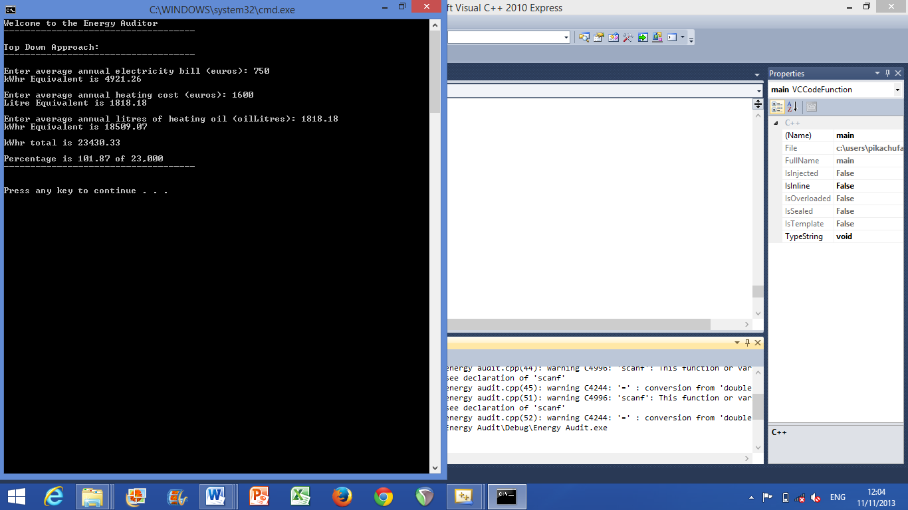

**Summary of findings:**

From writing this code and running it I was able to calculate the average electricity bill per annum to equal to 4921.26 kWhrs.

I calculated the average heating oil bill of €1600 for kerosene to equal 18509.07 kWhrs.

When these two figures were added the total for the house per year came in just over the national average of 23,000 kWhrs.

The final figure was 101.87% of 23,000.

In total based on an average bill per year we use 23430.10 kWhrs.

So, based on an average electricity bill per annum and given the current rates my home is just over the national average for energy usage here in Ireland.

**Bottom-Up Analysis:**

Screenshot of running code:

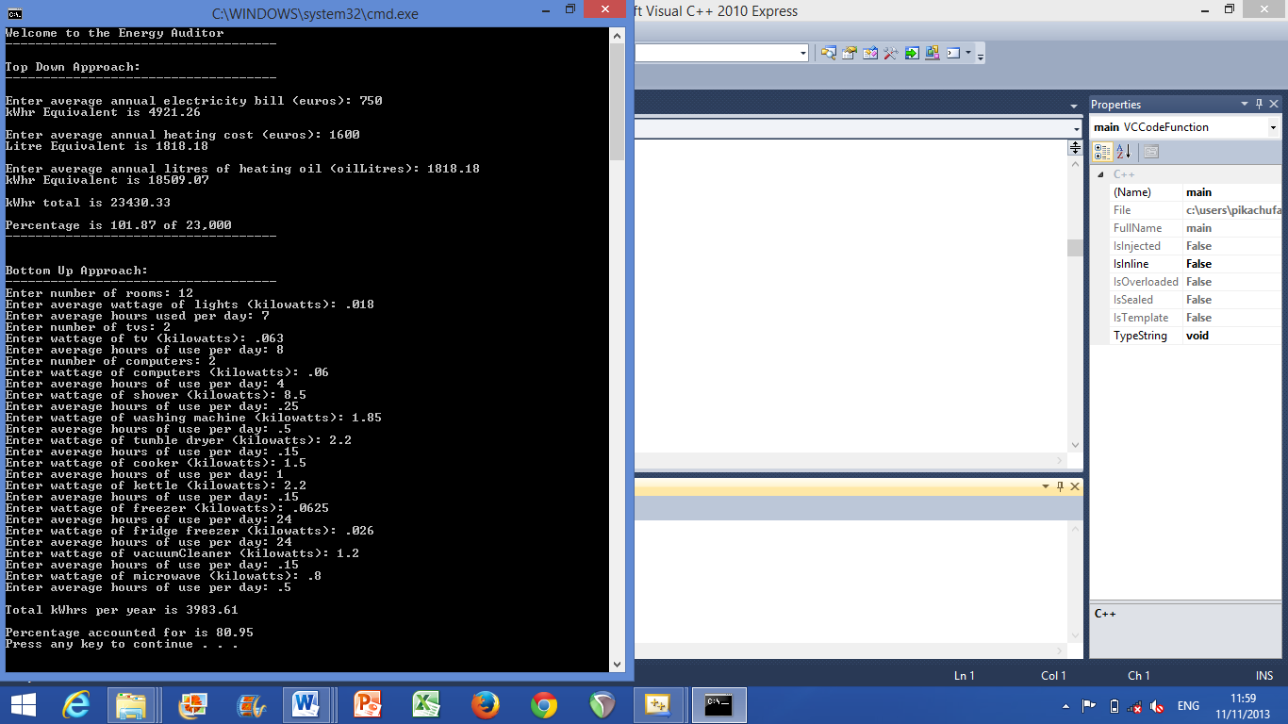

**Summary of findings:**

From writing this code and running it I was able to account for 80.95% of our electrical usage per annum.

I accomplished this by calculating the kWhr usage for various household appliances. These included:

2 43 inch plasma TVs, 2 computers, an electric shower, a washing machine, a tumble dryer, an electric cooker, a small chest freezer, a fridge freezer, a vacuum cleaner, a microwave and a kettle.

Given that not all items which require electricity to run were used, just the main ones, the percentage accounted for which I calculated was relatively accurate but not fully accurate, only 80.95% accurate.

For my overall percentage accounted for to be even higher I would need to do a more detailed analysis including all the electrical appliances throughout the house.

Also given all the values were averages and not exact figures for one year I am pleased with my percentage of success for this code.

**Source Code**

// Assignment - Week 7 Solution.cpp : Defines the entry point for the console application.

//

#include "stdafx.h"

#include <stdio.h>

#include <stdlib.h>

#include "string.h"

#include "math.h"

void main()

{

//Initialising

float euros;

float cost;

float litres;

float kWhr;

float oilLitres;

float kWhrTotal;

float percentage;

printf("Welcome to the Energy Auditor\n");

printf("------------------------------------\n\n");

printf("Top Down Approach:\n");

printf("------------------------------------\n\n");

// Electricity bill in euros to kWhr equivalent

printf ("Enter average annual electricity bill (euros): ");

scanf("%f", &euros);

cost = euros/0.1524;

printf ("kWhr Equivalent is %.2f\n\n", cost);

// Heating cost in euros to kerosene equivalent in litres

printf("Enter average annual heating cost (euros): ");

scanf("%f", &euros);

litres = euros/0.88;

printf ("Litre Equivalent is %.2f\n\n", litres);

// Kerosene in litres to kWhr equivalent

printf("Enter average annual litres of heating oil (oilLitres): ");

scanf("%f", &oilLitres);

kWhr = oilLitres * 10.18;

printf ("kWhr Equivalent is %.2f\n\n", kWhr);

// 1 litre of kerosene = 10.18 kWhr – got value from Google search www.graineco.com

// Calculate kWhr total for electricity and heating oil

kWhrTotal = cost + kWhr;

printf ("kWhr total is %.2f\n\n", kWhrTotal);

// Compare with average 23,000kWhr

percentage = ((kWhrTotal/23000)*100);

printf ("Percentage is %.2f of 23,000\n", percentage);

printf("------------------------------------\n\n\n");

// Bottom Up Approach

printf("Bottom Up Approach:\n");

printf("------------------------------------\n");

// Initialising

int rooms;

float lightWattage;

float lightUsage;

float lightkWhrs;

float sumkWhrs_lights;

// Calculate light kWhrs

printf("Enter number of rooms: ");

scanf("%d", &rooms);

printf("Enter average wattage of lights (kilowatts): ");

scanf("%f", &lightWattage);

printf("Enter average hours used per day: ");

scanf("%f", &lightUsage);

lightkWhrs = lightWattage*lightUsage;

sumkWhrs_lights = ((lightkWhrs*rooms)*365.00);

// Calculate tv kWhrs

int tvs;

float tvWattage;

float tvUsage;

float tvkWhrs;

float sumkWhrs_tv;

printf("Enter number of tvs: ");

scanf("%d", &tvs);

printf("Enter wattage of tv (kilowatts): ");

scanf("%f", &tvWattage);

printf("Enter average hours of use per day: ");

scanf("%f", &tvUsage);

tvkWhrs = tvWattage*tvUsage;

sumkWhrs_tv = ((tvkWhrs*tvs)*365.00);

// Calculate computer kWhrs

int computers;

float computerWattage;

float computerUsage;

float computerkWhrs;

float sumkWhrs_computer;

printf("Enter number of computers: ");

scanf("%d", &computers);

printf("Enter wattage of computers (kilowatts): ");

scanf("%f", &computerWattage);

printf("Enter average hours of use per day: ");

scanf("%f", &computerUsage);

computerkWhrs = computerWattage*computerUsage;

sumkWhrs_computer = ((computerkWhrs*computers)*365.00);

// Calculate shower kWhrs

float showerWattage;

float showerUsage;

float sumkWhrs_shower;

printf("Enter wattage of shower (kilowatts): ");

scanf("%f", &showerWattage);

printf("Enter average hours of use per day: ");

scanf("%f", &showerUsage);

sumkWhrs_shower = ((showerWattage*showerUsage)*365.00);

// Calculate washing maching kWhrs

float washingMachineWattage;

float washingMachineUsage;

float sumkWhrs_washingMachine;

printf("Enter wattage of washing machine (kilowatts): ");

scanf("%f", &washingMachineWattage);

printf("Enter average hours of use per day: ");

scanf("%f", &washingMachineUsage);

sumkWhrs_washingMachine = ((washingMachineWattage*washingMachineUsage)*365.00);

// Calculate tumble dryer kWhrs

float tumbleDryerWattage;

float tumbleDryerUsage;

float sumkWhrs_tumbleDryer;

printf("Enter wattage of tumble dryer (kilowatts): ");

scanf("%f", &tumbleDryerWattage);

printf("Enter average hours of use per day: ");

scanf("%f", &tumbleDryerUsage);

sumkWhrs_tumbleDryer = ((tumbleDryerWattage*tumbleDryerUsage)*365.00);

// Calculate small electric oven kWhrs

float cookerWattage;

float cookerUsage;

float sumkWhrs_cooker;

printf("Enter wattage of cooker (kilowatts): ");

scanf("%f", &cookerWattage);

printf("Enter average hours of use per day: ");

scanf("%f", &cookerUsage);

sumkWhrs_cooker = ((cookerWattage*cookerUsage)*365.00);

// Calculate kettle kWhrs

float kettleWattage;

float kettleUsage;

float sumkWhrs_kettle;

printf("Enter wattage of kettle (kilowatts): ");

scanf("%f", &kettleWattage);

printf("Enter average hours of use per day: ");

scanf("%f", &kettleUsage);

sumkWhrs_kettle = ((kettleWattage*kettleUsage)*365.00);

// Calculate small chest freezer kWhrs

float freezerWattage;

float freezerUsage;

float sumkWhrs_freezer;

printf("Enter wattage of freezer (kilowatts): ");

scanf("%f", &freezerWattage);

printf("Enter average hours of use per day: ");

scanf("%f", &freezerUsage);

sumkWhrs_freezer = ((freezerWattage*freezerUsage)*365.00);

// Calculate fridge freezer kWhrs

float fridgeFreezerWattage;

float fridgeFreezerUsage;

float sumkWhrs_fridgeFreezer;

printf("Enter wattage of fridge freezer (kilowatts): ");

scanf("%f", &fridgeFreezerWattage);

printf("Enter average hours of use per day: ");

scanf("%f", &fridgeFreezerUsage);

sumkWhrs_fridgeFreezer = ((fridgeFreezerWattage*fridgeFreezerUsage)*365.00);

// Calculate vacuum cleaner kWhrs

float vacuumCleanerWattage;

float vacuumCleanerUsage;

float sumkWhrs_vacuumCleaner;

printf("Enter wattage of vacuumCleaner (kilowatts): ");

scanf("%f", &vacuumCleanerWattage);

printf("Enter average hours of use per day: ");

scanf("%f", &vacuumCleanerUsage);

sumkWhrs_vacuumCleaner = ((vacuumCleanerWattage*vacuumCleanerUsage)*365.00);

// Calculate microwave kWhrs

float microwaveWattage;

float microwaveUsage;

float sumkWhrs_microwave;

printf("Enter wattage of microwave (kilowatts): ");

scanf("%f", &microwaveWattage);

printf("Enter average hours of use per day: ");

scanf("%f", &microwaveUsage);

printf("\n");

sumkWhrs_microwave = ((microwaveWattage*microwaveUsage)*365.00);

// Calculate total kWhrs for entire house

float totalkWhrs_house;

totalkWhrs_house = sumkWhrs_shower + sumkWhrs_washingMachine + sumkWhrs_tumbleDryer + sumkWhrs_cooker + sumkWhrs_kettle +

sumkWhrs_freezer + sumkWhrs_fridgeFreezer + sumkWhrs_vacuumCleaner + sumkWhrs_microwave + sumkWhrs_lights +

sumkWhrs_tv + sumkWhrs_computer;

printf("Total kWhrs per year is %.2f\n\n", totalkWhrs_house);

// Calculate percentage of electrical kWhrs accounted for

float percentageAccountedFor;

percentageAccountedFor = ((totalkWhrs_house/cost)*100);

printf ("Percentage accounted for is %.2f\n", percentageAccountedFor);

}

**Results from code:**

80.95% of electrical usage per annum accounted for.

Average cost of electricity bill = €750

Average electricity bill per annum = 4921.26 kWhrs.

Average cost of heating oil (kerosene) = €1600

Average heating oil bill of kerosene = 18509.07 kWhrs.

Total kWhrs per year came in just over the national average of 23,000 kWhrs.

The final figure was 101.87% of 23,000, which is 23430.10 kWhrs per annum.

**Screen shots:**

Top Down Approach:



Bottom Up Approach:

